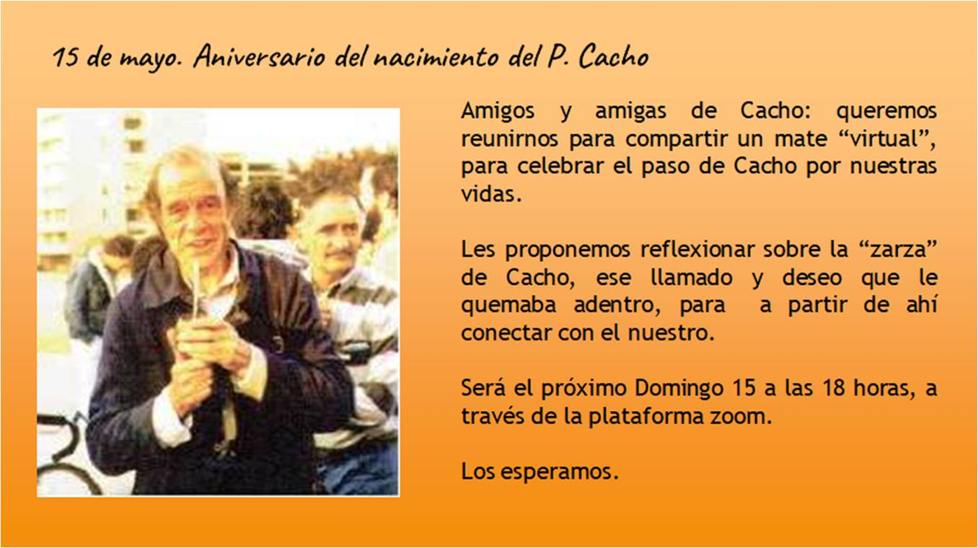
Time: May 15, 2022 06:00 PM Montevideo
https://us02web.zoom.us/j/89306932867
Meeting ID: 893 0693 2867

