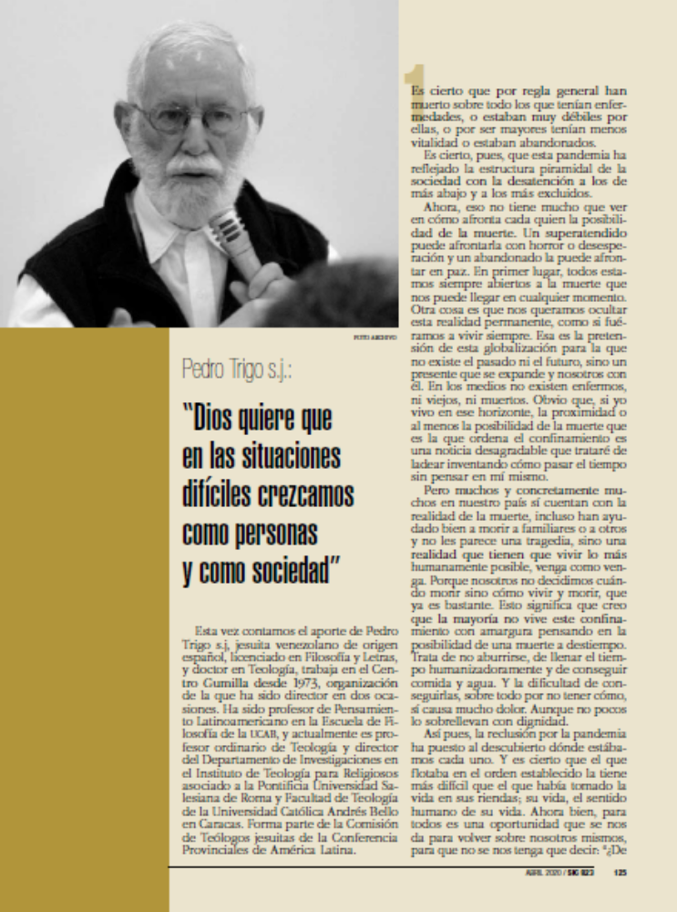

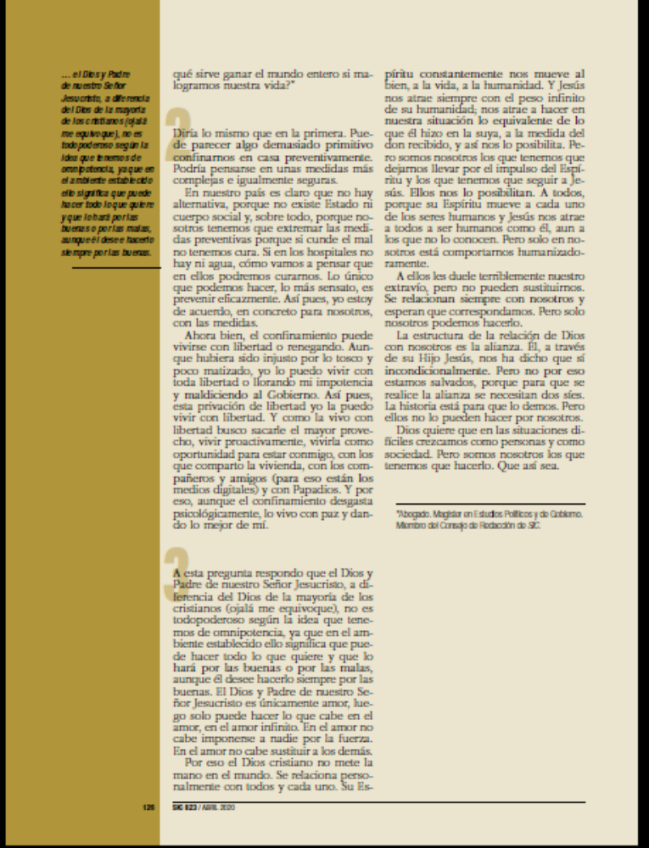
http://revistasic.gumilla.org/wp-content/uploads/2020/05/SIC-823.pdf

