Kairos Palestine on the statement made by His Holiness the Pope about peace in Palestine and Israel
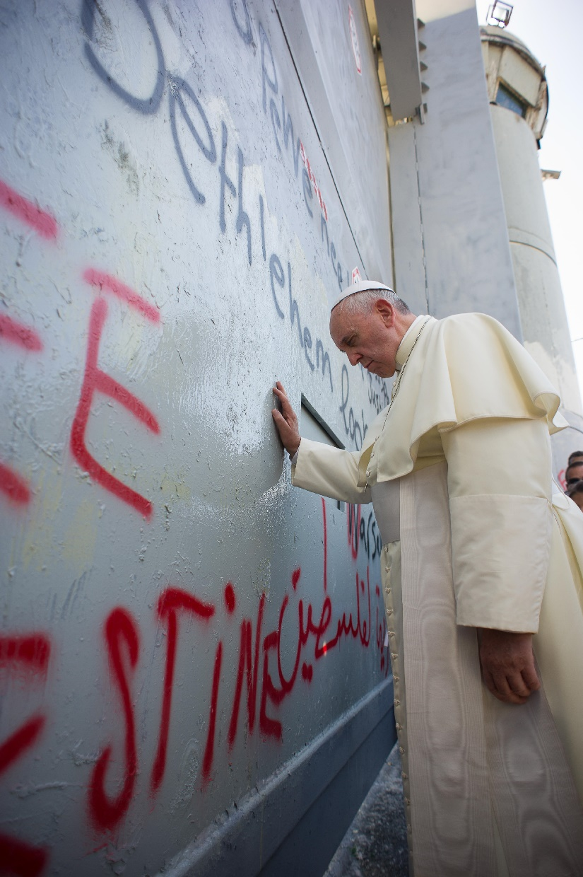
In his traditional speech on New Year’s Eve to accredited ambassadors to the Vatican, His Holiness Pope Francis tackled several international issues that require resolution. On the Palestinian problem, he stated that negotiations are the natural way to achieve the needed solution and to bring about a just peace between the two peoples.
While we thank His Holiness for his concern for the Palestinian people, we at the Palestinian Christian Initiative/Kairos Palestine wish to issue a reminder that Palestinians are actually dying and are not just living in a state of hostility or conflict. Our life has become unbearable. We are dying every day, oppressed every day, thrown in prisons every day, our land and homes are confiscated every day, and we are expelled from Jerusalem with our children every day. This is due to the Israeli military occupation that has been suffocating Palestinians for many decades, along with its continuous violation of our God-given human rights and of international legitimacy.
The Palestinian people tried to negotiate with their occupier for many years, but Israel has refused to abide by international law and UN resolutions. It has denied the right of Palestinians to an independent state, to end its discrimination against Palestinian citizens or to recognize the right of the Palestinian people to return to their land from which they were displaced in 1948 following the establishment of the state of Israel on three-quarters of the total area of historic Palestine. Israel is the party that closed the door on negotiations, which went on for more than thirty years to no avail due to Israel’s refusal to recognize the rights of Palestinians to have an independent state on their land. In fact, Israel exploited the fruitless negotiations to extend its control over the land by building settlements and the separation wall, and by continuing to deny even the Palestinian existence.
We the Palestinian people endorse a peaceful and just solution based on international law and UN resolutions. We accept serious political negotiations that lead to a just solution and reject fruitless negotiations that lead only to maintaining Israeli control over us and our land, a situation that we have been enduring for many decades.
The issue is now in the hands of the international community who should take the daring step to implement its resolutions according to international legitimacy by exerting pressure on Israel to accept a just solution for both peoples.
We thank His Holiness Pope Francis for his concern and ask His Holiness to state the following: Give justice to the Palestinian people because they are oppressed. Stop the policy of discrimination against them and allow them to live in an independent state. Respect their right to return to their land from which they were displaced. End the daily violations against them. With this, peace, justice and security will be established throughout the holy land and in the world.

http://www.kairospalestine.ps/index.php/kairos-palestine-blog/270-kairos-palestine-on-the-statement-made-by-his-holiness-the-pope-about-peace-in-palestine-and-israel

